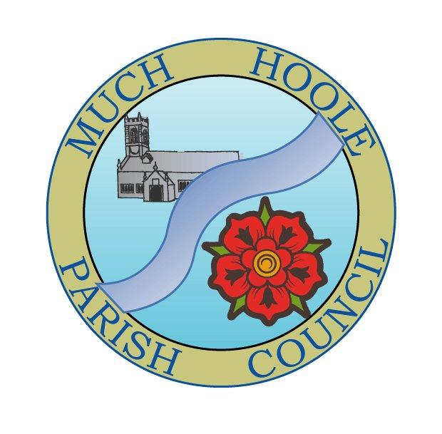 | MUCH HOOLE PARISH COUNCIL  NOTICE OF MEETING
You are hereby summoned to attend the Meeting of Much Hoole Parish Council to be held at 7.30pm on Monday 12th September 2022. The meeting will be held at the Venue (Hoole memorial village hall) Liverpool Road.
Russ Weaver, Clerk

AGENDA
1. | Apologies for Absence  To receive apologies for absence.  Cllr Taylor
2. | Declaration of Interests and Dispensations  - To receive declarations of interest from Councillors on items on the agenda  - To receive written requests for dispensations for disclosable pecuniary interests (if any)  - To grant any requests for dispensation as appropriate
3. | Minutes of the Previous Meetings  To resolve to approve as a correct record the Minutes of the Council Meeting held on the 11th July 2022
4. | Public Time  To invite and listen to issues raised by members of the public.
5. | Reports from other meetings  The Council will receive reports from meetings where Councillors have attended as representatives
6. | Off Road Cycle Track  To consider any updates on the Cycle track and resolve any actions required.
7. | Finance and Audit  To resolve to authorise payment of the following:  - To resolve to reimburse the Clerk £40.00 for printer inks  - All audit material has been submitted and all queries raised by the auditor have been answered. We are now awaiting the completed audit certificate(AGAR Part 3) from the external auditor PKF LIttleJohn, after which a notice of completion of audit will be posted on the website and notice boards.
8. | Community Projects update  To receive an update on any ongoing projects  - Village signage  - Following comments at the last meeting during public time, concerning the general appearance of the village, footpaths and hedges, a walking survey has been completed.  .
9. | Car Parking  Due to the absence of the Clerk due to illness, there has been no progress regarding liaison with LCC to increase roadside parking space around the recreation ground. However, enquiries to improve parking will continue.
10. | Planning  There are no applications relating to Much Hoole
11. | Village Hall development update  To receive and note a report on the progress of The Venue
12. | Footpaths  To receive an update on any public footpath repair or maintenance issues
13. | Grants  The availability of grants is on the Council website and notices will be posted on the notice boards  No new grant applications have been received
14. | Newsletter  The Council is asked to suggest topics and material for inclusion in the next newsletter
15. | Items for next agenda
17. | Date of Next Meeting  The Parish Council to agree the date of the next meeting as 7.30pm Monday 12th September 2022, to be held at ‘The Venue’, Liverpool Road, Much Hoole.

